A paper review about the Chapter 4 of the ENSEMBLE CONTROL OF ROBOTIC SYSTEMS by Aaron T. Becker

Yu Huang

1. **Goal of This Chapter**

The goal of this paper is to “derive a closed-loop feedback policy that guarantees exact asymptotic convergence of the ensemble to any given position” [1]. Here, the word “ensemble” specifically means an ensemble or group of robots which are basically simple robot “balls” or “wheels” made up of 5 degree of freedom. This chapter also thrived to implement the “asymptotic convergence” which is similar to the concept of “asymptotic stability” which means that the system of robots will converge to the stable point in the configuration space. Therefore, asymptotic convergence means theoretically those robot will gradually converge to a certain point when the given time for them to move is enough or in other word, the distances` sum between robots and the stable point will eventually approximate zero.

1. **Control Model of This Chapter**

As previously said, the robot here has 5 degree of freedom, however, every robot is actuated by 2 parameters that are forward speed u1 and rotation speed u2. Therefore, the system is the an under-actuated system which means the number of actuation parameters is lower than required by degree of freedom. The configuration of every robot is described as:

$q={[x,y,θ]}^{T}$ (2.1)[1]

Thus the mathematic model of this control problem can be described as:

$\dot{q}\left(t\right)=u_{1}\left(t\right)\left[\begin{matrix}\cos{θ} \\ \sin{θ} \\ 0\end{matrix}\right]+u_{2}(t)\left[\begin{matrix}0 \\ 0 \\ 1\end{matrix}\right]$ (2.2)[1]

Note that in order to prove the asymptotic stability of the system, the author firstly study the stability of the system consists of infinite robots and chose the integrated distance of all the robots as the Lyapunov Function to be the basis of the stability proof:

$V\left(t,x,y\right)=\int_{1-δ}^{1+δ}{\frac{1}{2ϵ}}\left(x^{2}\left(t,ε\right)+y^{2}\left(t,ε\right)\right)dε$ (2.3)[1]

Where: the $ε$ denotes a character of every individual robot which parameterize their difference. It can be the radius of a robot. Because it calculates the distance of an infinite ensemble of robots, we must use the integration.

To insure the stability of the ensemble system, the chapter required:

$u_{1}\left(t\right)=-\int_{1-δ}^{1+δ}{(x\left(t,ε\right)\cos\left(εt\right)+y(t,ε)\sin{(εt))dε}}$ (2.4)[1]

In this way, as the paper pointed, can we insure the $\dot{V}(t,x,y)$ to be negative semi-definite and make the system stable. It is also an approach for this paper to design a control principle.

Then, the paper invented the control policies as follows:

$u_{1}\left(t\right)=-\int_{1-δ}^{1+δ}{(x\left(t,ε\right)\cos\left(εt\right)+y(t,ε)\sin{(εt))dε}}$ (2.4)[1]

$u_{2}\left(t\right)=1$ (2.5)[1]

1. **Applications and Limitations**

The paper made theoretical extensions to unidirectional vehicles, finite ensemble of robots and discrete-time control policy. In order to make the general control policy make sense to the unidirectional vehicles like cars or micro-robots which are not likely to go backwards so often, the paper modified the u1(t) to make it no less than zero and as for the kind of scratch-drive robots which cannot make a pure rotation( have minimum rotation radii). The paper defined an imagine center for every robots so as to consider the motion as a sheer rotation. Besides, the paper made a further extension to the finite ensemble of robots involving a finite number of robots which are controlled or measured in discrete time. Therefore, the paper altered the u1(t) of the control policies from a continuous one to a discrete one that is from an integral to a sum of discrete term. Because the mathematic model of the control system here changed, the paper also offered the stability proof for this discrete model. The paper also devised a control policy for a discrete time circumstances that is command the robot to rotate in place for the first stage of a short time period and to travel at a linear velocity for the rest of the time period. After applying a noise mode, the author completed his simulation on MATLAB.

First is about the continuous time simulation, whose contribution is that it illustrated the principle of determining the k. As the result graph showed in the paper, k=2n is a bad choice whereas k=5n is a better choice. Details are demonstrated in the following graphs which are about the changing process of the error and control inputs at a continuous time.

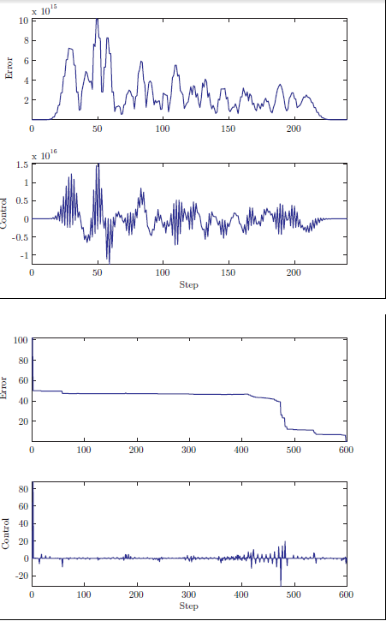

Figure 1: Error and control of a discrete-time finite ensemble of

n = 120 robots under control [1]

In order to prove the feasibility of the previous control policy of the discrete time control, the author also used the same technique as the previous one that is to observe the error change versus time under three different conditions: different $ε$ values(with or without noise and different noise levels), identical robots, noise exerted on rotation signals. Besides, this paper also exhibited hardware experiment using differential-drive robots that are different cars with different wheels sizes.

However, both the theoretical work and experimental work are based on 2 dimensional coordinates systems, therefore, future work about whether those control policies apply to 3-dimensional system can be done with the utilization of robots which can move in the 3 dimensional space like robotic drones. This chapter did not study the convergence time of the ensemble and avoided the discussion of the problem of convergence process, for example, how much space at least will the ensemble need so as to converge to the desired point.

[1] Becker, Aaron. "Ensemble control of robotic systems." PhD diss., University of Illinois at Urbana-Champaign, 2012.